MODULE IV
Different Anomalies in Designing a Database, The Idea of Normalization, Functional Dependency, Armstrong’s Axioms (Proofs Not Required), Closures and Their Computation, Equivalence of Functional Dependencies (FD), Minimal Cover (Proofs Not Required).
First Normal Form (1NF), Second Normal Form (2NF), Third Normal Form (3NF), Boyce Codd Normal Form (BCNF), Lossless Join and Dependency Preserving Decomposition, Algorithms for Checking Lossless Join (LJ) and Dependency Preserving (DP) Properties.
Different Anomalies in Designing a Database
Consider the simplified relational schema of COMPANY database.
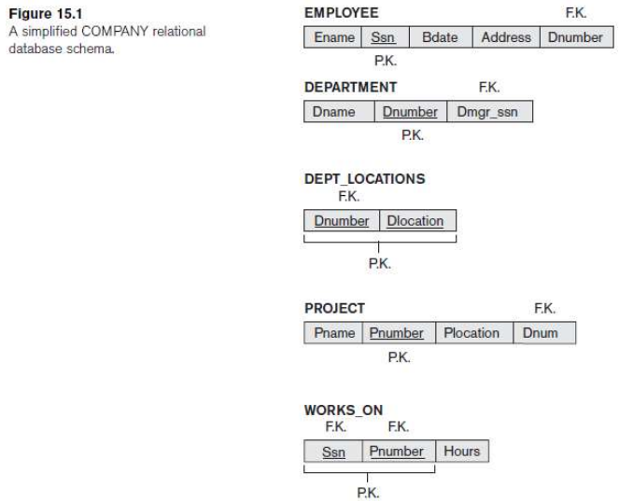
Suppose we are applying the NATURAL JOIN operator to EMPLOYEE and DEPARTMENT relations and also to EMPLOYEE and PROJECT and WORKS_ON relations.
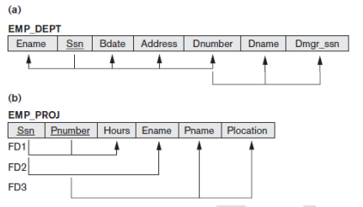(The students should ignore the lines under the relations for now; they are used to illustrate functional dependency notation, discussed in the next section).
A tuple in the EMP_DEPT relation schema represents a single employee but includes additional information—namely, the name (Dname) of the department for which the employee works and the Social Security number (Dmgr_ssn) of the department manager. For the EMP_PROJ relation, each tuple relates an employee to a project but also includes the employee name (Ename), project name (Pname), and project location (Plocation).
Although there is nothing wrong logically with these two relations, they are mixing attributes from distinct real-world entities: EMP_DEPT mixes attributes of employees and departments, and EMP_PROJ mixes attributes of employees and projects and the WORKS_ON relationship. They may be used as views, but they cause problems when used as base relations.
Storing natural joins of base relations leads to an additional problem referred to as update anomalies. These can be classified into insertion anomalies, deletion anomalies, and modification anomalies.
Insertion Anomalies- Insertion anomalies can be differentiated into two types, illustrated by the following examples based on the EMP_DEPT relation:
• To insert a new employee tuple into EMP_DEPT, we must include either the attribute values for the department that the employee works for, or NULLs (if the employee does not work for a department as yet). For example, to insert a new tuple for an employee who works in department number 5, we must enter all the attribute values of department 5 correctly so that they are consistent with the corresponding values for department 5 in other tuples in EMP_DEPT. In the design of Figure 1, we do not have to worry about this consistency problem because we enter only the department number in the employee tuple; all other attribute values of department 5 are recorded only once in the database, as a single tuple in the DEPARTMENT relation.
• It is difficult to insert a new department that has no employees as yet in the EMP_DEPT relation. The only way to do this is to place NULL values in the attributes for employee. This violates the entity integrity for EMP_DEPT because Ssn is its primary key. Moreover, when the first employee is assigned to that department, we do not need this tuple with NULL values any more. This problem does not occur in the design of Figure 1 because a department is entered in the DEPARTMENT relation whether or not any employees work for it, and whenever an employee is assigned to that department, a corresponding tuple is inserted in EMPLOYEE.
Deletion Anomalies- The problem of deletion anomalies is related to the second insertion anomaly situation just discussed. If we delete from EMP_DEPT an employee tuple that happens to represent the last employee working for a particular department, the information concerning that department is lost from the database. This problem does not occur in the database of Figure 1 because DEPARTMENT tuples are stored separately.
Modification Anomalies- In EMP_DEPT, if we change the value of one of the attributes of a particular department—say, the manager of department 5—we must update the tuples of all employees who work in that department; otherwise, the database will become inconsistent. If we fail to update some tuples, the same department will be shown to have two different values for manager in different employee tuples, which would be wrong.
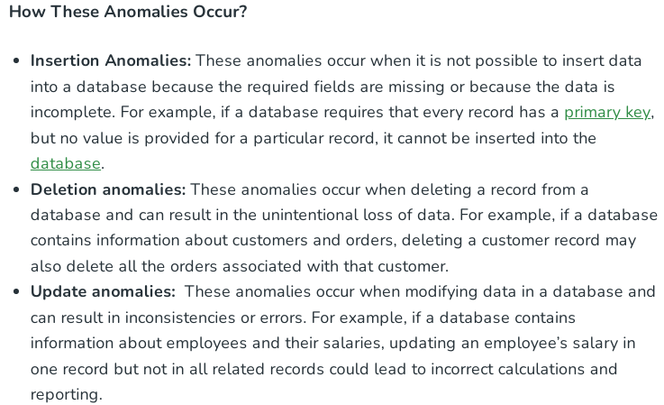
These anomalies can be avoided or minimized by designing databases that adhere to the principles of normalization.
Normalization of Relations
The normalization process, as first proposed by E.F Codd, takes a relation schema through a series of tests to certify whether it satisfies a certain normal form. The process, which proceeds in a top-down fashion by evaluating each relation against the criteria for normal forms and decomposing relations as necessary, can thus be considered as relational design by analysis. Initially, Codd proposed three normal forms, which he called first, second, and third normal form. A stronger definition of 3NF—called Boyce-Codd normal form (BCNF)—was proposed later by Boyce and Codd. All these normal forms are based on a single analytical tool: the functional dependencies among the attributes of a relation. Later, a fourth normal form (4NF) and a fifth normal form (5NF) were proposed, based on the concepts of multivalued dependencies and join dependencies, respectively.
Normalization of data can be considered a process of analyzing the given relation schemas based on their FDs and primary keys to achieve the desirable properties of
(1) minimizing redundancy and
(2) minimizing the insertion, deletion, and update anomalies.
It can be considered as a “filtering” or “purification” process to make the design have successively better quality. Unsatisfactory relation schemas that do not meet certain conditions—the normal form tests—are decomposed into smaller relation schemas that meet the tests and hence possess the desirable properties.
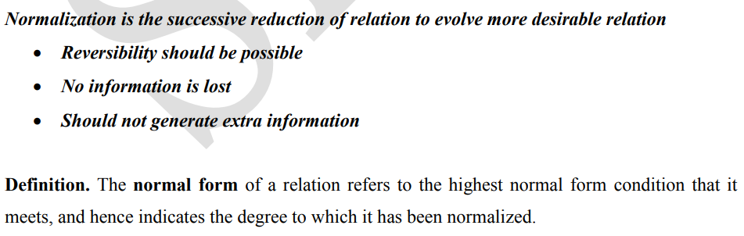
Functional Dependencies
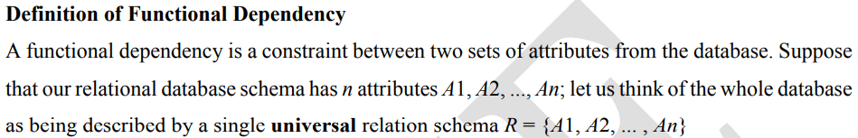
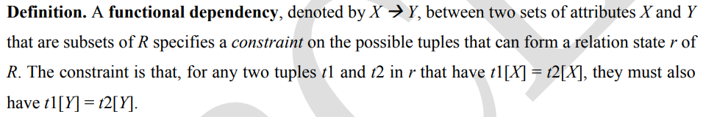
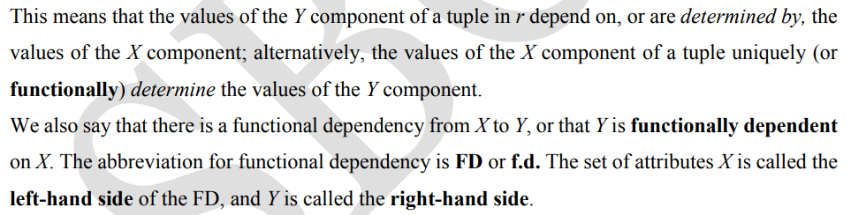
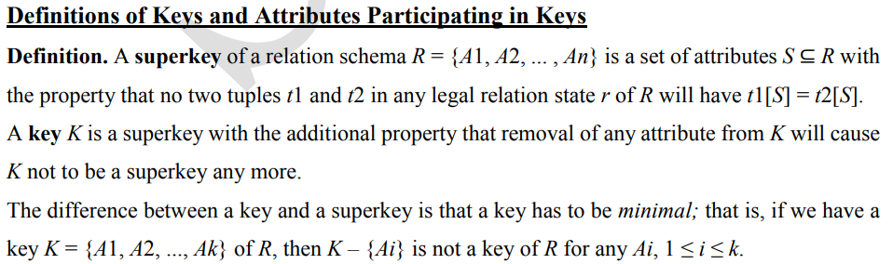
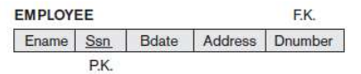
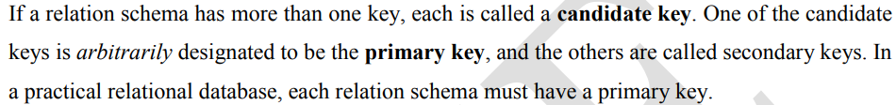
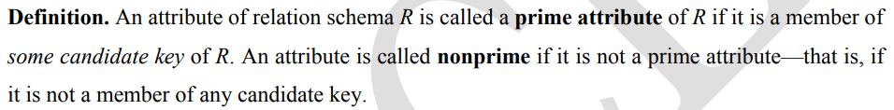
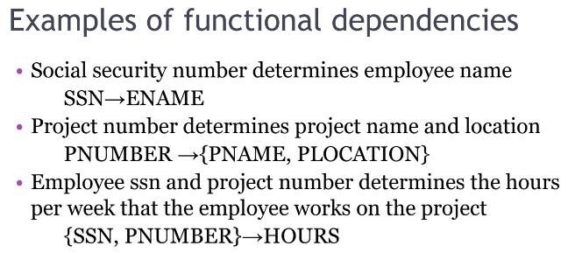
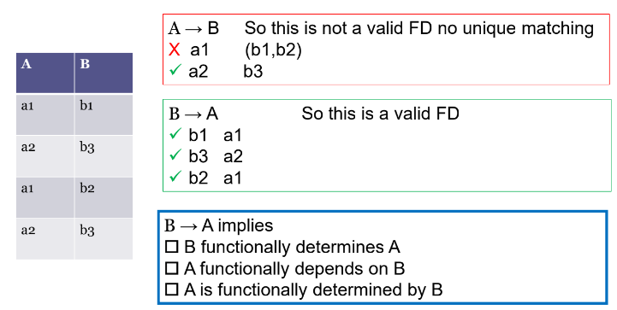
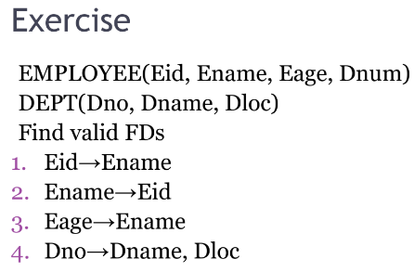
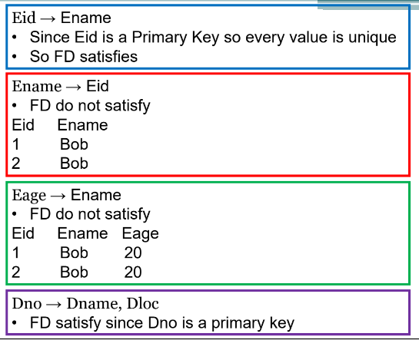

Armstrong’s Axioms (Properties of Functional Dependencies)
